Cancel/ inactivate the paper bid in Georgia Procurement Registry(GPR)
Step # | Action
1 | Login to GPR. Link: https://ssl.doas.state.ga.us/PRSapp/PR_login.jsp
2 | To upload the ‘Cancellation’ notice to the bid and inform all the associated suppliers about the cancellation Main Menu> Bid Processing> Add a document to a bid >(Select FY Year) Click on ‘Process’ > Select Bid> Click on ‘Browse’ to upload the attachment> Name the attachment> Click on ‘process’> Click on ’Return To Menu’ to go back.  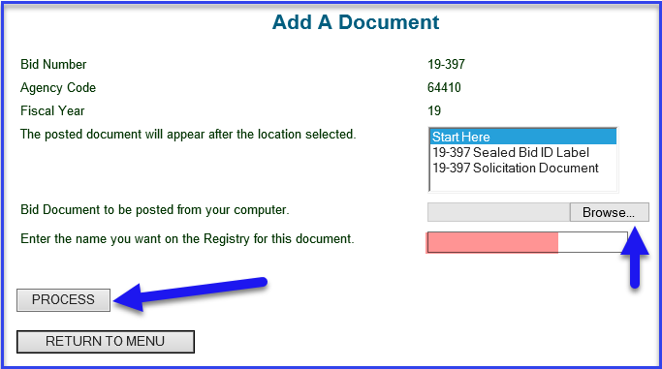  - Bid once posted on GPR cannot be deleted permanently.
3 | To cancel the bid --> Main Menu> Bid Processing> Edit a bid > (Select FY Year) Click ‘Process’ > Select Bid> Select 'Cancelled' from drop down next to Bid Activity Code.
 | End

